APPLICATION FORM
The National Disaster Recovery Fund for Archives (NDRFA), established by the Society of Southwest Archivists and the Society of American Archivists, provides grants of up to $5,000 to support the recovery of archival collections from major disasters. Any repository that holds archival records or special collections is eligible to apply for a grant; the repository need not be a member of SSA or SAA.
Grant funds are meant to support immediate recovery efforts within the first six months following a disaster. Grant monies may be used for the direct recovery of damaged or at-risk archival materials; such services as freeze drying, storage, transportation of materials, and rental facilities; supplies, including acid-free boxes and folders, storage cartons, cleaning materials, portable dehumidifiers, plastic milk crates, and protective gear; and to defray the costs for volunteers or other laborers who assist with the recovery. Grant monies are not intended for longer term preservation of collections or detailed preservation of collections. Activities such as infrastructure improvements or expenditures for permanent equipment such as scanners, shelving, or replacement cabinets are not an appropriate use of these funds.

Once an application is received, please allow five (5) business days for a response from the NDRFA Grant Review Committee. The committee may request additional information or clarification before making a final decision.
All grant awards are payable by check. Checks will be sent to the institutional address included on this form to the attention of the primary contact. Checks will be sent within one week of approval.

Recipients will be asked to provide a financial accounting of expenditures within 6 months of receiving the funding. A brief testimonial and pictures of recovery efforts are also appreciated.

Send your application/letter, via either email attachment or postal service, to:

Society of American Archivists Foundation
Attn: National Disaster Recovery Fund for Archives
17 North State Street, Suite 1425
Chicago, IL 60602
866-722-7858 (toll-free)
fax 312-606-0728
foundation@archivists.org
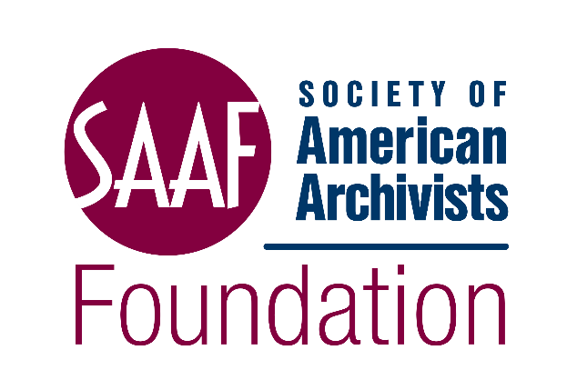

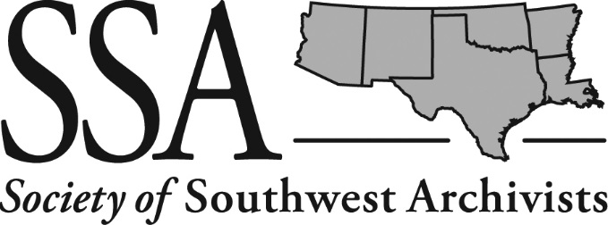

Application Instructions

Please provide as much detail as possible. Descriptions of the damaged materials (including quantities) are essential for the committee to understand the needs of the organization. It is also helpful to know what action has already been taken. A detailed budget outlining all expected costs related to the requested funding is critical. See the budget worksheet for guidance.

Name of Repository: ___________________________________________________________
Address: _______________________________________________________________________
City: _________________________ State: ________ Zip Code: ________ Country: _________
Phone Number: ____________ Fax: ____________ Email: _______________________

Head of Organization: ___________________________ Title: ___________________________
Phone Number: ____________ Fax: ____________ Email: _______________________

Primary Contact: ________________________________ Title: __________________________
Phone Number: _____________ Fax: ____________ Email: ______________________

Best way to make contact [i.e., phone, fax, or email]: __________________________

If selected, to whom should the check be made payable?

Mission of the Organization

Brief description of archival collection(s). What is the topical, geographic, organizational, or chronological focus/scope of the collection? What kinds of material are included (paper, photographs, video or audio recordings, computer discs or drives)? What is its estimated size? (Use specific measures like total number of cubic or linear feet or meters, or number of boxes, volumes, drawers.)
Brief description of damage to the affected collection(s). What parts of the collection are damaged? How much material is damaged (percentage of collection or number of feet, etc.)? What kind of damage was incurred (water, mold, dirt, contaminants, contents scattered, etc.)?

Proposed plan of work. Please describe your proposed plan of work for the recovery of your archival collections and how this grant fits in with any existing disaster plan or preservation plan. Additionally, please describe how this work will further recovery and preservation efforts for your collection materials overall.

How much funding is being requested (up to $5,000 USD)? Please provide a specific amount.

How will these funds be used? What specific services, supplies, or costs related to volunteers or other temporary help are you including?

Please provide specific information on the items/services you intend to purchase with NDRFA grant funds. (Please provide all amounts in US dollars.)
VENDOR | ITEM DESCRIPTION | UNIT PRICE (USD) | QTY. | SUBTOTAL (USD) | EST. SHIPPING | TOTAL (USD)

Project Assistant Fees. Provide the following information if additional staff are required to assist in recovery efforts.
Contact Information:
No. of days on project:
Daily rate of compensation ($):
Total (USD):
Total Requested from NDRFA (not to exceed $5,000)
Supplies | $
Consultants | $
Salary | $
TOTAL (USD) | $

What other funding sources are available to the repository?

